Continuously Controlled Damping (CCD) Control Function with Adaptive Drive– CGEA1.3

Functional Description

This STSS handles the setting of the vehicle’s variable damping system (a.k.a. Continously Controlled Damping, or CCD) and also called DSS (Driver Select Suspension), which employs user-selectable modes. The feature provides customers with different options to select the available damping modes via the settings menu. The Instrument Cluster uses the Personalization signals for the Message Center function to set these different options in the Vehicle Dynamics Module (VDM).

Depending on vehicle options, when CCD is present there will be a menu for either “Drive Control” or “Adaptive Drive”.
The “Adaptive Drive” damping system has 2 settings, one for when the PRNDS is in “S” (Sport) mode, and the other for “D” (Drive) mode. The “Adaptive Drive” menu also has PCM/ECM settings in addition to the VDM settings.

The “Adaptive Drive” menu is usually referred to as “Lincoln Sport Mode – Phase 2”, or “Adaptive Drive – Phase 2”. Phase 2 includes PCM/ECM settings in addition to VDM settings.

For the “Adaptive Drive” vehicle, a persistent indication of whether the driver has selected “Sport” or “Comfort” is shown. The HMI at this time is a red ring around speedo and tach with the word “Sport” or a blue ring around the speedo and tach with the word “Comfort”.

The PCM/ECM settings are accomplished using signals DrvPerfMde_D_DsplyPt and DrvPerfMde_D_Rq.

This STSS also handles the CCD warnings, which informs the driver in case there is a system fault or if the system is unavailable due to a fault. In case of a warning, the setup feature is made unavailable to the driver.

The customer uses the message center switches and display to set the CCD settings in the vehicle.

Interfaces

Interface Context Diagram (I/O Block Diagram)
Figure 1 CCD Function Context Diagram
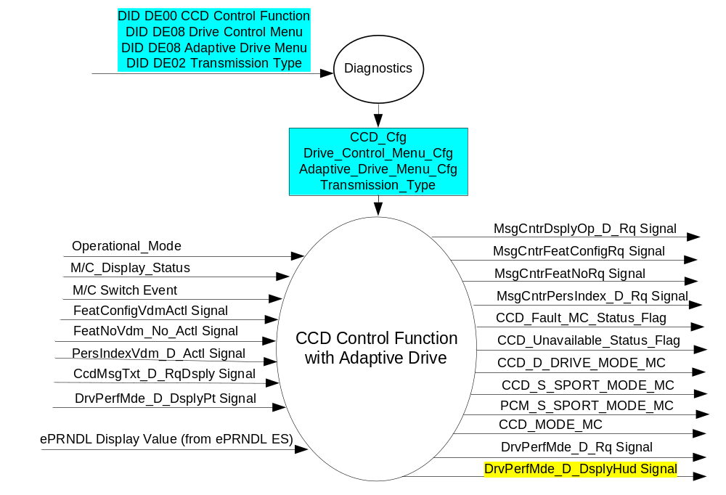

Inputs
- INTERNAL:
- Operational_Mode
- M/C Switch Event
- M/C_Display_Status
- CCD_Cfg
- Drive_Control_Menu_Cfg
- Adaptive_Drive_Menu_Cfg
- Transmission_Type
- ePRNDL Display Value (From ePRNDL ES, Table 1, section 3.1.1.1)

- MUX signals on the CAN Bus from VDM

- FeatConfigVdmActl Signal
Signal Name | Size (bits) | Detail | Units | Res. | Offset | State Encoded | Min | Max
FeatConfigVdmActl | 16 | - | Undefined | 1 | 0 |  | 0  (0x0) | 65535  (0xFFFF)

- FeatNoBcm_No_Actl Signal
Signal Name | Size (bits) | Detail | Units | Res. | Offset | State Encoded | Min | Max
FeatNoVdm_No_Actl | 16 | - | Number | 1 | 0 |  | 0  (0x0) | 65535  (0xFFFF)

- PersIndexBcm_D_Actl Signal
Signal Name | Size (bits) | Detail | Units | Res. | Offset | State Encoded | Min | Max
PersIndexVdm_D_Actl | 3 |  | SED | 1 | 0 |  | 0  (0x0) | 7  (0x7)
 |  | PERS_1 |  |  |  | 0 (0x0)
 |  | PERS_2 |  |  |  | 1 (0x1)
 |  | PERS_3 |  |  |  | 2 (0x2)
 |  | PERS_4 |  |  |  | 3 (0x3)
 |  | Vehicle |  |  |  | 4 (0x4)
 |  | Unused |  |  |  | 5(0x5)
 |  | Unused |  |  |  | 6 (0x6)
 |  | Unused |  |  |  | 7 (0x7)

- CcdMsgTxt_D_RqDsply Signal
Signal Name | Size (bits) | Detail | Units | Res. | Offset | State Encoded | Min | Max
CcdMsgTxt_D_RqDsply | 3 |  | SED | 1 | 0 |  | 0  (0x0) | 7  (0x7)
 |  | No_Mode_Selected |  |  |  | 0 (0x0)
 |  | Comfort |  |  |  | 1 (0x1)
 |  | Normal |  |  |  | 2 (0x2)
 |  | Sport |  |  |  | 3 (0x3)
 |  | Faulted |  |  |  | 4 (0x4)
 |  | CCD_Service_Required |  |  |  | 5(0x5)
 |  | CCD_Temporarily_Off |  |  |  | 6 (0x6)
 |  | Mode_Change_Unavailable |  |  |  | 7 (0x7)

- MUX signals on the CAN Bus from PCM/ECM

- DrvPerfMde_D_DsplyPt Signal
Signal Name | Size (bits) | Detail | Units | Res. | Offset | State Encoded | Min | Max
DrvPerfMde_D_DsplyPt | 2 |  | SED | 1 | 0 |  | 0  (0x0) | 3  (0x3)
 |  | No_Mode_Selected |  |  |  | 0 (0x0)
 |  | Not Used |  |  |  | 1 (0x1)
 |  | Normal |  |  |  | 2 (0x2)
 |  | Sport |  |  |  | 3 (0x3)

Outputs
- CCD_D_DRIVE_MODE_MC, CCD_S_SPORT_MODE_MC, PCM_S_SPORT_MODE_MC, CCD_MODE_MC
- CCD_Fault_MC_Status_Flag
- CCD_Unavailable_MC_Status_Flag
- MUX signals on the CAN Bus

- MsgCntrDsplyOp_D_Rq Signal
Signal Name | Size (bits) | Detail | Units | Res. | Offset | State Encoded | Min | Max
MsgCntrDsplyOp_D_Rq | 3 |  | SED | 1 | 0 |  | 0  (0x0) | 1  (0x7)
 |  | NULL |  |  |  | 0 (0x0)
 |  | QUERY |  |  |  | 1 (0x1)
 |  | SET |  |  |  | 2 (0x2)
 |  | UPLOAD |  |  |  | 3 (0x3)
 |  | RESTORE |  |  |  | 4 (0x4)
 |  | COPY |  |  |  | 5(0x5)
 |  | Not used |  |  |  | 6 (0x6)
 |  | Not Used |  |  |  | 7 (0x7)
.
- MsgCntrFeatConfigRq Signal
Signal Name | Size (bits) | Detail | Units | Res. | Offset | State Encoded | Min | Max
MsgCntrFeatConfigRq | 16 |  | Undefined | 1 | 0 |  | 0  (0x0) | 65535  (0xFFFF)

- MsgCntrFeatNoRq Signal
Signal Name | Size (bits) | Detail | Units | Res. | Offset | State Encoded | Min | Max
MsgCntrFeatNoRq | 16 |  | Number | 1 | 0 |  | 0  (0x0) | 65535  (0xFFFF)

- MsgCntrPersIndex_D_Rq
Signal Name | Size (bits) | Detail | Units | Res. | Offset | State Encoded | Min | Max
MsgCntrPersIndex_D_Rq | 3 |  | SED | 1 | 0 |  | 0  (0x0) | 1  (0x7)
 |  | PERS_1 |  |  |  | 0 (0x0)
 |  | PERS_2 |  |  |  | 1 (0x1)
 |  | PERS_3 |  |  |  | 2 (0x2)
 |  | PERS_4 |  |  |  | 3 (0x3)
 |  | Vehicle |  |  |  | 4 (0x4)
 |  | Not Used |  |  |  | 5 (0x5)
 |  | Not Used |  |  |  | 6 (0x6)
 |  | Not Used |  |  |  | 7 (0x7)

- DrvPerfMde_D_Rq Signal
Signal Name | Size (bits) | Detail | Units | Res. | Offset | State Encoded | Min | Max
DrvPerfMde_D_Rq | 2 |  | SED | 1 | 0 |  | 0  (0x0) | 3  (0x3)
 |  | No_Mode_Selected |  |  |  | 0 (0x0)
 |  | Not Used |  |  |  | 1 (0x1)
 |  | Normal |  |  |  | 2 (0x2)
 |  | Sport |  |  |  | 3 (0x3)

- DrvPerfMde_D_Rq Signal
Signal Name | Size (bits) | Detail | Units | Res. | Offset | State Encoded | Min | Max
DrvPerfMde_D_DsplyHud | 2 |  | SED | 1 | 0 |  | 0x0 | 0x3
DrvPerfMde_D_DsplyHud |  | None |  |  |  | 0x0
DrvPerfMde_D_DsplyHud |  | Sport |  |  |  | 0x1
DrvPerfMde_D_DsplyHud |  | Comfort |  |  |  | 0x2
DrvPerfMde_D_DsplyHud |  | Not used |  |  |  | 0x3

Function/Performance

Operational Modes

Mode | Differentiating Vehicle Conditions
Sleep Mode | CCD Control Function Text Messages Disabled
Limiting Mode | CCD Control Function Text Messages Disabled
Normal Mode | CCD Control Function Text Messages Enabled / Disabled
Crank Mode | CCD Control Function Text Message Enabled / Disabled

Voltage Levels

Refer to the Cluster Features table located in the Operational Modes and Voltage Range Strategies Section in this SPSS.

Human-Machine Interface

Visual

Indicator Graphics / Display Format
For program specific display, refer to “<Program> Cluster Menu Structure.xls”.
Example Menu Graphics:

With Drive_Control_Menu_Cfg = Enabled:

Menu Level 2 | Menu level 3 |  |  |  | Menu level 4
Driver Assist |  | Drive Control |  | ❍ | Sport
 |  |  |  | ● | Normal
 |  |  |  | ❍ | Comfort

With Adaptive_Drive_Menu_Cfg = Enabled:

Menu level 2 |  | Menu level 3 |  | Menu level 4 |  | Menu level 5
Vehicle |  | Drive Control |  | T: Drive Control
 |  |  |  | Handling in "D" |  | T: Handling in "D"
 |  |  |  |  | ❍ | Sport
 |  |  |  |  | ● | Normal
 |  |  |  |  | ❍ | Comfort
 |  |  |  | Handling in "S" |  | T: Handling in "S"
 |  |  |  |  | ❍ | Sport
 |  |  |  |  | ● | Normal
 |  |  |  | Performance in "S" |  | T: Performance in "S"
 |  |  |  |  | ❍ | Sport
 |  |  |  |  | ● | Normal

Note: “Handling in D” and “Handling in S” are VDM settings. “Performance in S” is a PCM/ECM setting.

Example of “Sport” selected for Adaptive Drive:
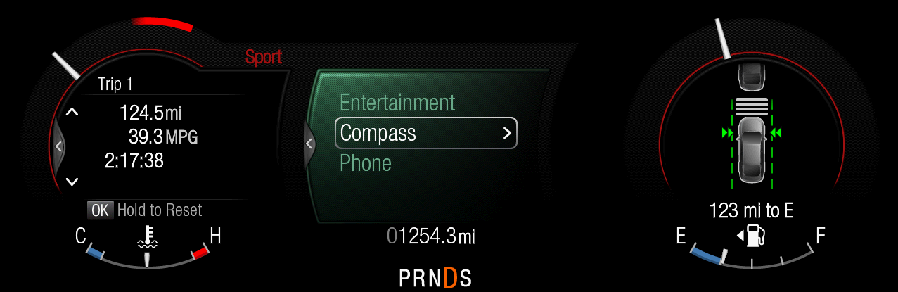
Note: See translation matrix for “Sport” translations. Also, the text will timeout, but the red rings persist.

Example of “Comfort” selected for Adaptive Drive:
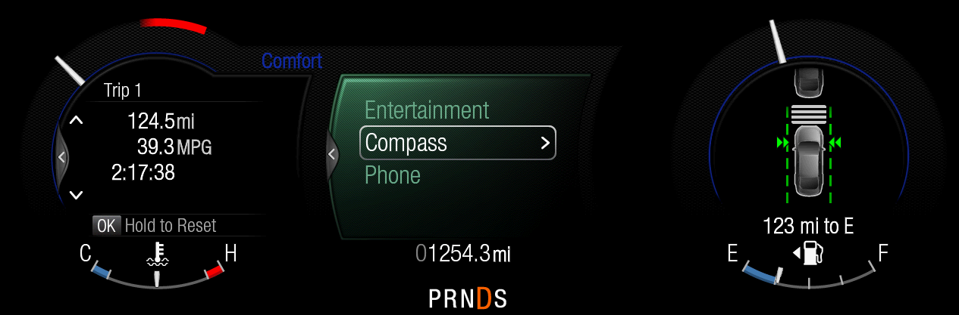
Note: See translation matrix for “Comfort” translations. Also, the text will timeout, but the blue rings persist.

Indicator Color Coordinates

Reference section COLOR & ILLUMINATION REQUIREMENTS (GRAPHICS)

Indicator Characteristics

Refer to Message Center X Display_Y Button Interface Section, where X and Y are appropriate values in this document.

Audio

None

Switch Control Logic

Consumer access to the CCD Control Configuration shall be as specified in the message center basic functionality display as specified in Message Center X Display_Y Button Interface Section, where X and Y are appropriate values in this document.

System Accuracy

Within a 100msec of receiving a message that results in a change of state the cluster will update the display to the proper status.

Operation: Performance and Functional

Subsystem Algorithm Flowchart / State Diagram

Figure 2 CCD Diagnostic Configuration Flowchart
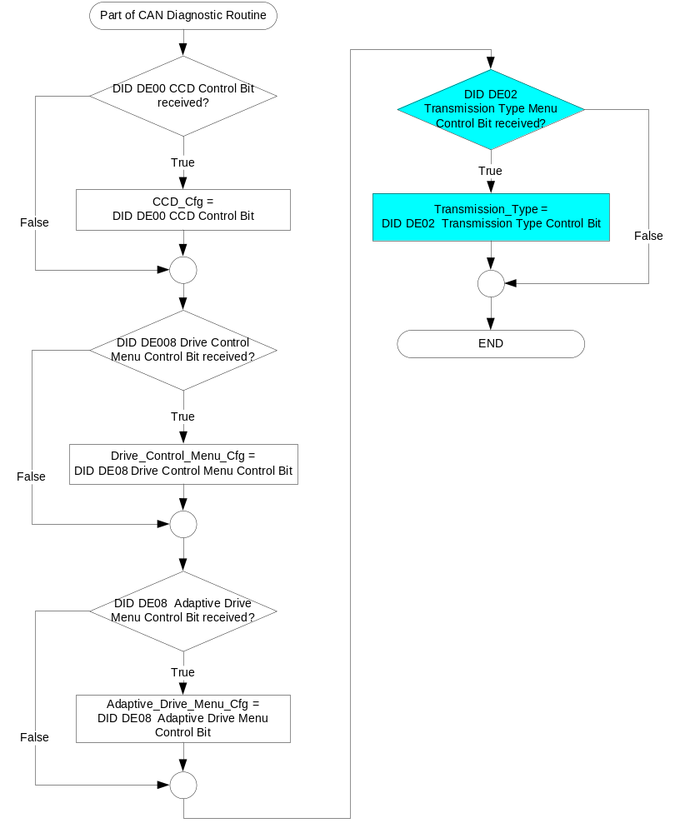

Figure 3: CCD/PCM input request Flowcharts

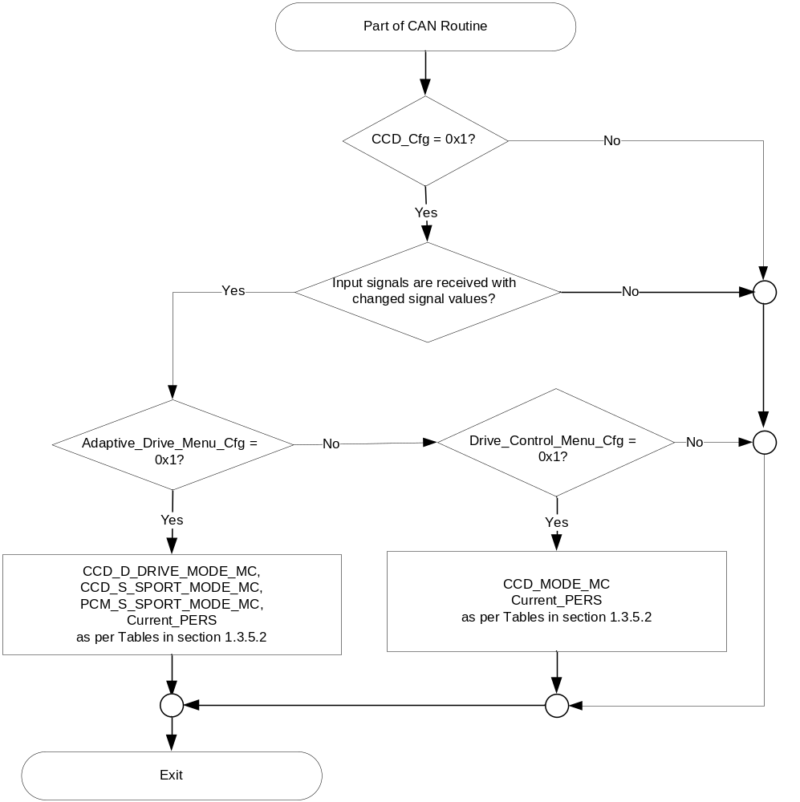

Figure 4: CCD/PCM output SET request Flowchart

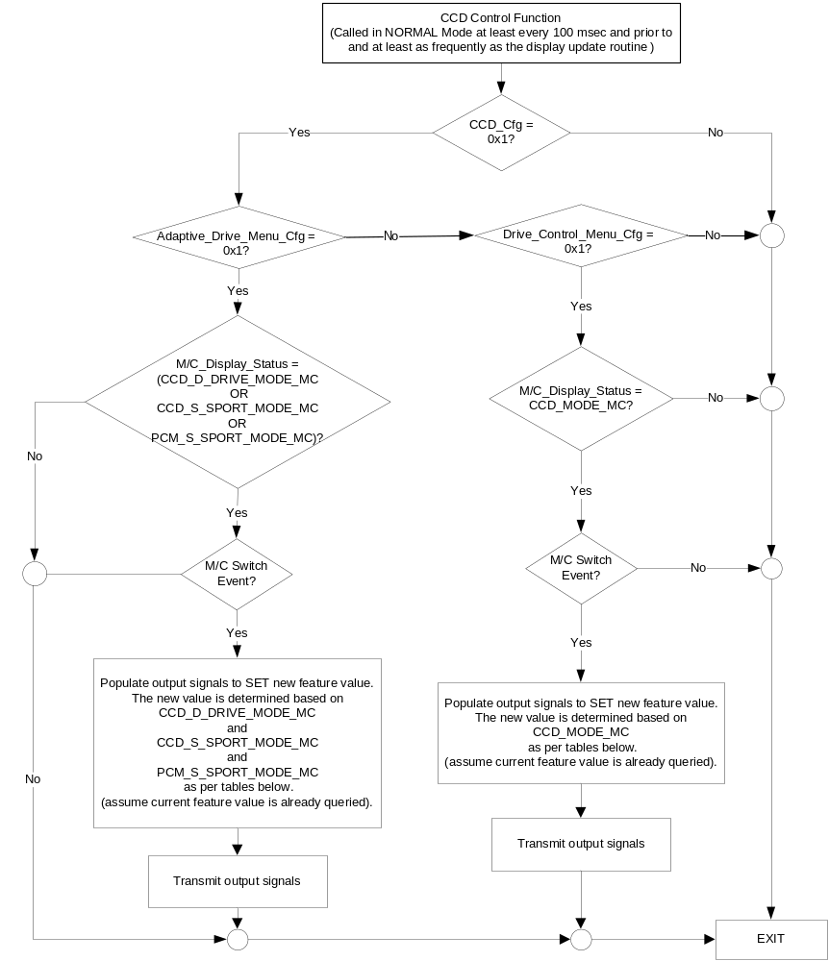
NOTE: In the CCD Control Function Flowchart, the definition of "M/C Switch Event" is defined in Message Center X Display_Y Button Interface Section, where X and Y are appropriate values in this document.

- CCD_MODE_MC State Assignment
FeatNoVdmActl | FeatConfigVdmActl | PersIndexVdm_D_Actl | CCD_Mode_MC | Current_PERS ⁽³⁾
0x0B00 ⁽¹⁾ | Comfort  (0x0001) | 0x0 – 0x4 | Comfort  (0x1) | 0x0 – 0x4
0x0B00 ⁽¹⁾ | Normal  (0x0002) | 0x0 – 0x4 | Normal  (0x2) | 0x0 – 0x4
0x0B00 ⁽¹⁾ | Sport  (0x0003) | 0x0 – 0x4 | Sport  (0x3) | 0x0 – 0x4
0x0B00 ⁽¹⁾ | Other ⁽²⁾ |  | Error  (0x4) | Last Known
Missing per Section 1.4.1 ⁽²⁾ |  |  | Error  (0x4) | Last Known

⁽¹⁾ CCD Drive Mode Enable Feature Number. Reference is Feat Num table in “Vehicle Personalization FS”
⁽²⁾ Message data is Faulted
⁽³⁾ Equal to the received “PersIndex<--->” signal value . When faulted Keep last known value.

- Message Center Display and MC CCD Request Messages

based upon CCD_MODE_MC
CCD_MODE_MC | Display Menu | 5-Button Switch Selection Event | MsgCntrDsplyOp_D_Rq  Signal | MsgCntrFeatNoRq  Signal | MsgCntrFeatConfigRq  Signal | MsgCntrPersIndex_D_Rq  Signal
Sport  (0x3) | 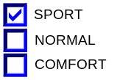 | Up/Down + OK (Select NORMAL or COMFORT) | SET (0x2) | 0x0B00 | 0x0002 (if NORMAL is selected)  0x0001 (if COMFORT Is selected) | Current_PERS
Normal  (0x2) | 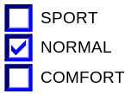 | Up/Down + OK (Select SPORT or COMFORT) | SET (0x2) | 0x0B00 | 0x0003 (if SPORT is selected)  0x0001 (if COMFORT Is selected) | Current_PERS
Comfort  (0x1) | 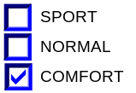 | Up/Down + OK (Select SPORT or NORMAL ) | SET (0x2) | 0x0B00 | 0x0003 (if SPORT is selected)  0x0002 (if NORMAL is selected) | Current_PERS
Error  (0x4) | 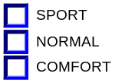 | Up/Down + OK (Select SPORT, NORMAL or COMFORT) | SET (0x2) | 0x0B00 | 0x0003 (if SPORT is selected)  0x0002 (if NORMAL is selected)  0x0001 (if COMFORT is selected) | Current_PERS

- CCD_D_DRIVE_MODE_MC State Assignment
FeatNoVdmActl | FeatConfigVdmActl | PersIndexVdm_D_Actl | CCD_D_DRIVE_MODE_MC | Current_PERS ⁽³⁾
0x0B00 ⁽¹⁾ | Comfort  (0x0001) | 0x0 – 0x4 | Comfort  (0x1) | 0x0 – 0x4
0x0B00 ⁽¹⁾ | Normal  (0x0002) | 0x0 – 0x4 | Normal  (0x2) | 0x0 – 0x4
0x0B00 ⁽¹⁾ | Sport  (0x0003) | 0x0 – 0x4 | Sport  (0x3) | 0x0 – 0x4
0x0B00 ⁽¹⁾ | Other ⁽²⁾ |  | Error  (0x4) | Last Known
Missing per Section 1.4.1 ⁽²⁾ |  |  | Error  (0x4) | Last Known

⁽¹⁾ CCD Drive Mode Enable Feature Number. Reference is Feat Num table in “Vehicle Personalization FS”
⁽²⁾ Message data is Faulted
⁽³⁾ Equal to the received “PersIndex<--->” signal value . When faulted Keep last known value.

- Message Center Display and MC CCD Request Messages

based upon CCD_D_DRIVE_MODE_MC
CCD_D_  DRIVE_  MODE_MC | Display Menu | 5-Button Switch Selection Event | MsgCntrDsplyOp_D_Rq  Signal | MsgCntrFeatNoRq  Signal | MsgCntrFeatConfigRq  Signal | MsgCntrPersIndex_D_Rq  Signal
Sport  (0x3) |  | Up/Down + OK (Select NORMAL or COMFORT) | SET (0x2) | 0x0B00 | 0x0002 (if NORMAL is selected)  0x0001 (if COMFORT Is selected) | Current_PERS
Normal  (0x2) |  | Up/Down + OK (Select SPORT or COMFORT) | SET (0x2) | 0x0B00 | 0x0003 (if SPORT is selected)  0x0001 (if COMFORT Is selected) | Current_PERS
Comfort  (0x1) |  | Up/Down + OK (Select SPORT or NORMAL ) | SET (0x2) | 0x0B00 | 0x0003 (if SPORT is selected)  0x0002 (if NORMAL is selected) | Current_PERS
Error  (0x4) |  | Up/Down + OK (Select SPORT, NORMAL or COMFORT) | SET (0x2) | 0x0B00 | 0x0003 (if SPORT is selected)  0x0002 (if NORMAL is selected)  0x0001 (if COMFORT is selected) | Current_PERS

- CCD_S_SPORT_MODE_MC State Assignment
FeatNoVdmActl | FeatConfigVdmActl | PersIndexVdm_D_Actl | CCD_S_SPORT_MODE_MC | Current_PERS ⁽³⁾
0x0B01 ⁽¹⁾ | Normal  (0x0002) | 0x0 – 0x4 | Normal  (0x2) | 0x0 – 0x4
0x0B01 ⁽¹⁾ | Sport  (0x0003) | 0x0 – 0x4 | Sport  (0x3) | 0x0 – 0x4
0x0B01 ⁽¹⁾ | Other ⁽²⁾ |  | Error  (0x4) | Last Known
Missing per Section 1.4.1 ⁽²⁾ |  |  | Error  (0x4) | Last Known

⁽¹⁾ CCD Sport Mode Enable Feature Number. Reference is Feat Num table in “Vehicle Personalization FS”
⁽²⁾ Message data is Faulted
⁽³⁾ Equal to the received “PersIndex<--->” signal value . When faulted Keep last known value.

- Message Center Display and MC CCD Request Messages

based upon CCD_S_SPORT_MODE_MC
CCD_S_  SPORT_  MODE_MC | Display Menu | 5-Button Switch Selection Event | MsgCntrDsplyOp_D_Rq  Signal | MsgCntrFeatNoRq  Signal | MsgCntrFeatConfigRq  Signal | MsgCntrPersIndex_D_Rq  Signal
Sport  (0x3) | 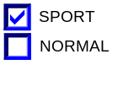 | Up/Down + OK (Select NORMAL) | SET (0x2) | 0x0B01 | 0x0002 (if NORMAL is selected) | Current_PERS
Normal  (0x2) | 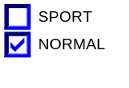 | Up/Down + OK (Select SPORT) | SET (0x2) | 0x0B01 | 0x0003 (if SPORT is selected) | Current_PERS
Error  (0x4) | 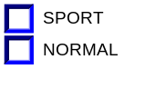 | Up/Down + OK (Select SPORT or NORMAL) | SET (0x2) | 0x0B01 | 0x0003 (if SPORT is selected)  0x0002 (if NORMAL is selected) | Current_PERS

- PCM_S_SPORT_MODE_MC State Assignment
DrvPerfMde_D_DsplyPt | PCM_S_SPORT_MODE_MC
0x0 (No_Mode_Selected) | Error  (0x4)
0x1 (Not Used) | Error  (0x4)
0x2 (Normal) | Normal  (0x2)
0x3 (Sport) | Sport  (0x3)
Missing per Section 1.4.1 | Error  (0x4)

- Message Center Display and MC PCM Request Messages

based upon PCM_S_SPORT_MODE_MC
PCM_S_  SPORT_  MODE_MC | Display Menu | 5-Button Switch Selection Event | DrvPerfMde_D_Rq Signal
Sport  (0x3) |  | Up/Down + OK (Select NORMAL) | 0x2 (if NORMAL is selected)
Normal  (0x2) |  | Up/Down + OK (Select SPORT) | 0x3 (if SPORT is selected)
Error  (0x4) |  | Up/Down + OK (Select SPORT or NORMAL) | 0x3 (if SPORT is selected)  0x2 (if NORMAL is selected)

- State Matrix for CCD Warning Status Flags
Operational_Mode | CCD_Config | CcdMsgTxt_D_RqDsply Signal | CCD_Fault_  MC_Status_Flag  (W1026 for Ford brand)  (W1027) for Lincoln) | CCD_Unavailable_  Status_Flag
Normal or Crank | Enabled (0x1) | Faulted (0x4) | Active | Active
Normal or Crank | Enabled (0x1) | Mode_Change_Unavailable (0x7) | Inactive | Active
Normal | Enabled (0x1) | Missing as per 1.4.1 | Inactive | Inactive
All Other Cases |  |  | Inactive | Inactive

Figure 5: Comfort/Sport Display Flowchart

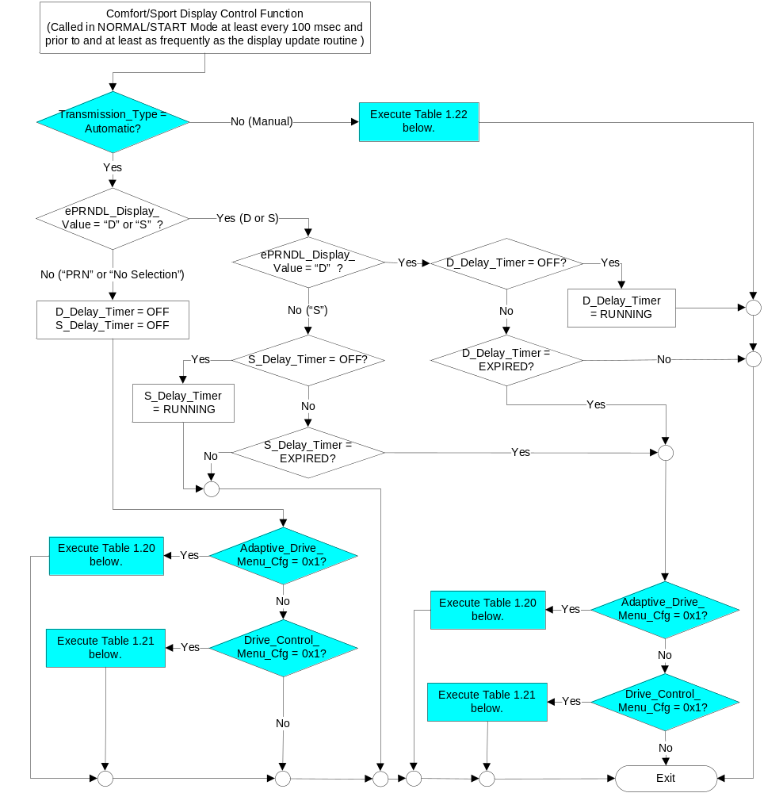

- State Matrix for Comfort/Sport Persistent Indication and CAN signal DrvPerfMde_D_DsplyHud - With Adaptive_Drive_Menu_Cfg = Enabled
Operational_Mode | CCD_Config | Adaptive_Drive_Menu_Cfg | ePRNDL Display Value | ePRNDL Display Value | Handling in “D” | Handling in “S” | Performance in “S” | Text Indication* | DrvPerfMde_D_  DsplyHud CAN signal** | Backlight  Rings
Normal or Crank | Enabled (0x1) | Enabled (0x1) | “D” | “D” | Sport | X | X | “Sport” | Sport (0x1) | Red
Normal or Crank | Enabled (0x1) | Enabled (0x1) | “D” | “D” | Normal | X | X | None | None (0x0) | None
Normal or Crank | Enabled (0x1) | Enabled (0x1) | “D” | “D” | Comfort | X | X | “Comfort” | Comfort (0x2) | Blue
Normal or Crank | Enabled (0x1) | Enabled (0x1) | “S” | “S” | X | Sport | Sport | “Sport” | Sport (0x1) | Red
Normal or Crank | Enabled (0x1) | Enabled (0x1) | “S” | “S” | X | Sport | Normal | “Sport” | Sport (0x1) | Red
Normal or Crank | Enabled (0x1) | Enabled (0x1) | “S” | “S” | X | Normal | Sport | “Sport” | Sport (0x1) | Red
Normal or Crank | Enabled (0x1) | Enabled (0x1) | “S” | “S” | X | Normal | Normal | None | None (0x0) | None
Normal or Crank | Enabled (0x1) | Enabled (0x1) | “P” or “R” or “N” | “P” or “R” or “N” | X | X | X | None | None (0x0) | None
Normal or Crank | Enabled (0x1) | Enabled (0x1) | “No Selection” | “No Selection” | X | X | X | None | No State Change | No State Change
All other cases |  |  |  |  |  |  |  | None | None (0x0) | None
*Note: Text Indication will timeout 10s (programmable Text_Indication_Timer) after a transition to any row. Backlight rings remain after Text Indication times out.
**Note: CAN signal DrvPerfMde_D_DsplyHud is used by the AHUD. Thus, it may not be necessary to transmit on every program.

- State Matrix for Comfort/Sport Persistent Indication and CAN signal DrvPerfMde_D_DsplyHud - With Drive_Control_Menu_Cfg = Enabled (Automatic Transmission)
Operational_Mode | CCD_Config | Adaptive_Drive_Menu_Cfg | Drive_Control_Menu_Cfg | ePRNDL Display Value | CCD_Mode_MC | Text Indication* | DrvPerfMde_D_  DsplyHud CAN signal** | Backlight  Rings
Normal or Crank | Enabled (0x1) | Disabled (0x0) | Enabled (0x1) | “P” or “R” or “N” or “D” or “S” | Sport  (0x3) | “Sport” | Sport (0x1) | Red
 |  |  |  |  | Comfort  (0x1) | “Comfort” | Comfort (0x2) | Blue
 |  |  |  |  | Normal  (0x2) | None | None (0x0) | None
All other cases |  |  |  |  |  | None | None (0x0) | None
*Note: Text Indication will timeout 10s (programmable Text_Indication_Timer) after a transition to any row. Backlight rings remain after Text Indication times out.
**Note: CAN signal DrvPerfMde_D_DsplyHud is used by the AHUD. Thus, it may not be necessary to transmit on every program.

- State Matrix for Comfort/Sport Persistent Indication and CAN signal DrvPerfMde_D_DsplyHud - With Drive_Control_Menu_Cfg = Enabled (Manual Transmission)
Operational_Mode | CCD_Config | Adaptive_Drive_Menu_Cfg | Drive_Control_Menu_Cfg | CCD_Mode_MC | Text Indication* | DrvPerfMde_D_  DsplyHud CAN signal** | Backlight  Rings
Normal or Crank | Enabled (0x1) | Disabled (0x0) | Enabled (0x1) | Sport  (0x3) | “Sport” | Sport (0x1) | Red
 |  |  |  | Comfort  (0x1) | “Comfort” | Comfort (0x2) | Blue
 |  |  |  | Normal  (0x2) | None | None (0x0) | None
All other cases |  |  |  |  | None | None (0x0) | None
*Note: Text Indication will timeout 10s (programmable Text_Indication_Timer) after a transition to any row. Backlight rings remain after Text Indication times out.
**Note: CAN signal DrvPerfMde_D_DsplyHud is used by the AHUD. Thus, it may not be necessary to transmit on every program.

Operation Description (supports algorithm flowchart /state diagram)
- When CCD_Unavailable_Status_Flag = Active OR CCD_Fault_MC_Status_Flag = Active, the setup feature shall be made unavailable to the user by graying out the selections on the display. The display shall be visible, however, the user should not be able to change or make any selection under the Setup menu. All selection options should be cleared until valid data is received.
- For definition of how the Message Center arbitrates and displays Active warnings, see the Warning / Alert Display Logic Diagram, located in the Message Center – X Display with W Button Interface section of this SPSS (where X and W are appropriate values in this document).
- There shall be a short delay (D_Delay_Timer and S_Delay_Timer) after the user has shifted the PRNDS to either “D” or “S” before the text indication appears and the backlight rings change color. This is to avoid “flashes” if the user is shifting through “D” to “S”. This is described in Figure 5 Comfort/Sport Display Flowchart.
- Text_Indication_Timer shall be internally programmable from 4s to 20s in 1s increments. Shall also be programmable for NO timeout. Default is 10s.
- Personalization Feature Number definitions:
Feature Name | Feature Num | Cfg Num | Cfg Value | MyKey Limited | Personalization Type
CCD Gear in Drive | 0x0B00 | 0x00 | No Mode Selected | Full | Movable
CCD Gear in Drive | 0x0B00 | 0x01 | Comfort | Full | Movable
CCD Gear in Drive | 0x0B00 | 0x02 | Normal | Full | Movable
CCD Gear in Drive | 0x0B00 | 0x03 | Sport | Full | Movable
CCD Gear in Sport | 0x0B01 | 0x00 | No Mode Selected | Full | Movable
CCD Gear in Sport | 0x0B01 | 0x01 | Comfort | Full | Movable
CCD Gear in Sport | 0x0B01 | 0x02 | Normal | Full | Movable
CCD Gear in Sport | 0x0B01 | 0x03 | Sport | Full | Movable
Note: 0x0B00 Feature Number is used for both “Drive Control” menu and “Adaptive Drive” menu.

Function Safety Classification (EMC)

Class B

Memory Storage
Parameter Name | Description | Value at  Battery Connect | Value at  Module Wake-up
CCD_MODE_MC | Output displayed in the M/C for CCD setting in Drive Control Menu. | Disabled (0x0) | Do Not Init
CCD_D_DRIVE_MODE_MC | Output displayed in the M/C for CCD setting when transmission is in “D” (drive) in Adaptive Drive Menu. | Disabled (0x0) | Do Not Init
CCD_S_SPORT_MODE_MC | Output displayed in the M/C for CCD setting when transmission is in “S” (sport) in Adaptive Drive Menu. | Disabled (0x0) | Do Not Init
CCD_Fault_MC_Status_Flag | State variable used by M/C Warning Arbitrator | Inactive | Inactive
CCD_Unavailable_Status_Flag | State variable used by M/C to enable/disable Setup options. | Inactive | Inactive
DrvPerfMde_D_Rq Signal | Output signal to PCM. This signal only changes when the user makes a menu selection. | No_Mode_Selected (0x0) | No_Mode_Selected (0x0)
DrvPerfMde_D_DsplyHud Signal | Output signal to AHUD so that it can mirror the Drive Mode. | None (0x0) | None (0x0)
ePRNDL Display Value | Currently displayed gear on ePRNDL (i.e. PRNDS321) | As per ePRNDL ES | As per ePRNDL ES
PCM_S_SPORT_MODE_MC | Output displayed in the M/C for PCM setting when transmission is in “S” (sport) in Adaptive Drive Menu. | Disabled (0x0) | Do Not Init
MsgCntrDsplyOp_D_Rq Signal | Output Signal to indicate Request Type. | NULL (0x0) | Do Not Init
MsgCntrFeatNoRq Signal | Output Signal to indicate Feature Number. | (0x0000) | Do Not Init
MsgCntrFeatConfigRq Signal | Output Signal to Specify the desired feature Value. | (0x0000) | Do Not Init
MsgCntrPersIndex_D_Rq Signal | Output Signal to indicate which personality profile is being accessed. | Vehicle (0x4) | Do Not Init
FeatNoVdm_No_Actl Signal | Input signal sent from BCM to indicate Feature Number. | (0x0000) | Do Not Init
FeatConfigVdmActl Signal | Input signal sent from BCM to indicate current value of the feature setting for the feature that is being set or queried. | (0x0000) | Do Not Init
PersIndexVdm_D_Actl Signal | Input signal sent from BCM to indicate which personality profile is being reported. | Vehicle (0x4) | Do Not Init
CcdMsgTxt_D_RqDsply Signal | Input signal send from VDM | Normal (0x2) | Normal (0x2)
CCD_Cfg | Configures cluster to allow CCD. Set to Disabled at Cluster Supplier Manufacturing Plant. | Use Stored Value | Use Stored Value
M/C_Display_Status | State Indicator to identify which text is currently being displayed on Message Center display. See * | See * below | See * below
M/C Switch Event | Event that is indicated as per the switch interface for the Message Center. See * | See * below | See * below
Operational_Mode | 4 state indicator for cluster operational mode | Limited | Limited, Normal or Crank
* Refer to Message Center X Display_Y Button Interface Section, where X and Y are appropriate values in this document.

Timers:
Parameter Name | Description | Value at  Battery Connect | Value at  Module Wake-up
D_Delay_Timer | Timer used to establish a delay before the text indication for either “Comfort” or “Sport” appears and the backlight rings change color after the user has shifted the PRNDS to “D”.  States:  OFF  RUNNING  EXPIRED – After 500ms of RUNNING | OFF | OFF
S_Delay_Timer | Timer used to establish a delay before the text indication for either “Comfort” or “Sport” appears and the backlight rings change color after the user has shifted the PRNDS to “S”.  States:  OFF  RUNNING  EXPIRED – After 500ms of RUNNING | OFF | OFF
Text_Indication_Timer | Timer to determine how long “Sport” or “Comfort” remains after a transition. Shall be internally programmable from 4s to 20s in 1s increments. Shall also be programmable for NO timeout. Default is 10s. | Not Active | Not Active

Reconfigurable Telltale

Not Applicable

Prove Out

Not applicable

Message Center Msg

Refer to Message Center Function description reference: Message IDs W1026.

Error Handling

Missing Message Strategy

The signals will be declared missing as per the Diagnostics section of this SPSS.

DTCs states and history will be determined as per the Diagnostics section of this SPSS.

If CCD_Cfg = Disabled, the cluster shall never log a missing message for this feature.

Diagnostics

Self Test

None

Engineering Test Mode

Reference section “Dealer / Engineering Test Mode (ETM)”

Part II Performance

Supported Diagnostic Trouble Codes (DTCs)
DTC | Description
C12200 | Lost Communication with Vehicle Dynamics Control Module
C10000 | Lost communication with ECM/PCM

DID DExx:
Block  Num | Block Description | Size (bits) | Byte(s) | Bits | State: Description | "0" | "1" | Default | Comments/Information
PACKETED BLOCKS
$00 | Option Content (B&A) | 1 | * | * | CCD Control Function | Disabled | Enabled | Disabled | Disabled means the VDM is not present in the vehicle. Enable whenever the VDM is present in the vehicle.
$08 | Option Content (B&A) | 1 | * | * | Drive Control Menu | Disabled | Enabled | Disabled | When enab led, the Drive Control Menu is displayed in the cluster Driver Assist menu. Feature requires VDM module in vehicle.  When VDM is present, enable EITHER Drive Control Menu (for Ford), OR Adaptive Drive Menu (for Lincoln), but NOT both!  Disabled means the menu is not present in the vehicle
$08 | Option Content (B&A) | 1 | * | * | Adaptive Drive Menu | Disabled | Enabled | Disabled | When enab led, the “Drive Control -> Handling in ‘D’/ Handling in ‘S’ / Perfomance in ‘S’ “ Menu is displayed in the cluster Vehicle menu. Feature requires VDM module in vehicle.  When VDM is present, enable EITHER Drive Control Menu (for Ford), OR Adaptive Drive Menu (for Lincoln), but NOT both!  Disabled means the menu is not present in the vehicle
$02 | Option Content (B&A) | 1 | * | * | Transmission Type | Automatic | Manual | Automatic  (0) | Set to vehicle transmission type.
*Byte and bit location to be identified in Part II Specification for this cluster

Part II Reference – NOTE: THIS IS NOT A REQUIREMENT SECTION. IT IS A REFERENCE GUIDE TO THE IC D&R and NETCOM TO DEVELOP THE VSCS.

- There are 3 STSS’ involved with CCD (VDM) and AFS (SASM). These are:
CCD Control Function w Adaptive Drive - CGEA1.3_vx.x.doc
Adaptive Steering Control Function - CGEA1.3_vx.x.doc (The table below is duplicated in this STSS as well)
Active Front Steering RTT and Messages - CGEA 1.3_vx.x.doc

- There are 5 different configuration parameters involved for 8 vehicle variants. Below is a summary that will assist in setting up the VSCS.

Adaptive Steering/Lincoln Adaptive Drive Configuration Table:
Vehicle Description | AFS_Cfg  (Turns on AFS RTT and Warnings W2125-W2128) | Adaptive_Steering_Manual_  Menu_Cfg  (Turns on “Adaptive Steering – Sport/Normal” menu) | Adaptive_Steering_Menu_Cfg  (Turns on “Adaptive Steering in Drive/Sport” menus) |  | CCD_Cfg:  Allows CcdMsgTxt_D_RqDsply signal, which triggers:  W1026 Ford  W1027 Lincoln | Drive_Control_Menu_Cfg  (Turns on “Drive Control – Sport/Normal/Comfort” menu) | Adaptive_Drive_Menu_Cfg  (Turns on Lincoln “Drive Control Handling in D/S, Performance in S” menus)
Lincoln with CCD only | Disabled | Disabled | Disabled |  | Enabled  (will show W1027) | Disabled | Enabled
Lincoln with CCD and AFS | Enabled | Disabled | Disabled |  | Enabled  (will show W1027) | Disabled | Enabled
Lincoln with AFS | Enabled | Disabled | Enabled |  | Disabled | Disabled | Disabled
Ford with AFS and Auto Trans (no CCD) | Enabled | Disabled | Enabled |  | Disabled | Disabled | Disabled
Ford with AFS and Manual Trans (no CCD) | Enabled | Enabled | Disabled |  | Disabled | Disabled | Disabled
Ford with CCD and AFS | Enabled | Disabled | Disabled |  | Enabled  (will show W1027) | Enabled | Disabled
Ford with CCD only | Disabled | Disabled | Disabled |  | Enabled  (will show W1027) | Enabled | Disabled
Ford No AFS, No CCD | Disabled | Disabled | Disabled |  | Disabled | Disabled | Disabled

Reference Specification

None.

Revision History
SPSS Module Revision History
Revision Level | Name | Change Description | Date
1.0 | V. Patel | Initial release | 9/28/2010
2.0 | S.Watkins | Major changes due to the implementation of “Lincoln Sport Mode”. Now, the CCD settings will vary on whether the PRNDS is “D” (Drive Mode) or “S” (Sport Mode). Thus, there is a new menu item. The original menu item was renamed CCD_D_DRIVE_MODE_MC, and the new menu is CCD_S_SPORT_MODE_MC.  - Section 1.2.1 - Updated Figure 1 with CCD_S_DRIVE_MODE_MC and CCD_S_SPORT_MODE_MC  - Section 1.3.3.2. – Updated graphics to show 2nd menu  - Slightly modified Figure 3 and Figure 4 for new CCD SPORT mode.  - Added Table 1.10 and 1.11 for CCD SPORT mode | 3/24/2011
3.0 | S. Watkins | Reason for change: Major update to include PCM settings for “Phase 2” of Adaptive Drive (a.k.a Lincoln Sport Mode). Also graphic updates, removed choice of “comfort” from “handling in S” mode.  Phase 2 starts with CGEA 1.3 Lincoln platforms.  - Changed filename to include “with Adaptive Drive”  - Section 1.1 – Added description of “Lincoln Sport Mode”  - Section 1.2.1, 1.2.2 – Added signal DrvPerfMde_D_DsplyPt  - Section 1.2.1, 1.2.3 – Added signal DrvPerfMde_D_Rq  - Section 1.2.3 – Added output PCM_S_SPORT_MODE_MC  - Section 1.3.3.2 – Updated graphics, and removed “comfort” as a choice from “Handling in S”. Also added “Performance in S”  - Section 1.3.5.1 – Updated Figure 3 and Figure 4 for PCM_S_SPORT_MODE_MC  - Section 1.3.5.2 – Updated Table 1.10 and Table 1.11 to remove “comfort”. Added new Table 1.14 and Table 1.15.  - Section 1.3.5.4 – Updated with new signals. | 5/25/2011
4.0 | S. Watkins | Lincoln programs desired to add a more persistent indication of whether in Sport or Comfort mode. HMI proposal accepted by Lisa Drake is to use Red rings and the word “Sport” and Blue rings and the word “Comfort”.  Combined meeting minutes from Sherri Bettendorf and Rich Kreder emails:  Here is a description of how they want it to function:  Direction was to have the words sport/comfort go away after a TBD timeout in the following scenarios:  - Change of state: when the logic denotes a change i.e. normal to sport, normal to comfort, sport to comfort or comfort to sport, etc.  - Wait until D or S is selected to determine the proper state and display for 10sec. I don’t see a reason to show mode in P/N/R (its not really applicable at that point). In all cases, the red/blue rings will stay when comfort or sport are active (no time out)  - It would be best to make the TBD timeout supplier/configurable and one of the configuration states should be “no timeout” in case at a later date we find out they want a change to no time out of the words  - Quiet mode will continue to show red/blue rings (and words for timeout period).  - Initial target for timeout, 10 seconds?  Changes highlighted in yellow throughout:  - Section 1.1 – Added description of new “Sport” and “Comfort” displays  - Section 1.2.1 – Added “ePRNDL Display Value” to Context diagram  - Section 1.2.2 - Added “ePRNDL Display Value”  - Section 1.3.3.2 – Added HMI pictures for Sport and Comfort.  - Section 1.3.5.1 – Added new Figure 5, Comfrt/Sport Display Flowchart  - Section 1.3.5.1 – Added new Table 1.17, State Matrix for Comfort/Sport Persisistent Indication  - Section 1.3.5.2 – Added 2 new bullet points for timers  - Section 1.3.5.4 – Added new parameters: ePRNDL Display Value, D_Delay_Timer, S_Delay_Timer, Text_Indication_Timer. | 3/20/2013
5.0 | S. Watkins | Major STSS re-write to handle both CCD menus (both the new “Drive Control” and the existing “Adaptive Drive”). This is per Jeremy Rawlings and approved in DI Change Control on 10/9/2014. Updates are directed first for CD539E/X and CD390. Changes marked in yellow throughout, but treat as new STSS.  Also note that W1026 has been obsoleted. It has been decided to use W1027 on all vehicles with CCD. | 11/13/2014
6.0 | S. Watkins | Modifed to add a CAN signal (DrvPerfMde_D_DsplyHud) for the AHUD. The cluster STSS for Drive Mode Control Mirror - CGEA1.3 also internally uses this signal.  - Section 1.2.1 – Added signal DrvPerfMde_D_DsplyHud to Figure 1  - Section 1.2.3 – Added Table 1.10 for DrvPerfMde_D_DsplyHud  - Section 1.3.5.1 – Added column in Table 1.20 for DrvPerfMde_D_DsplyHud  - Section 1.3.5.4 – Added row for DrvPerfMde_D_DsplyHud | 1/13/2015
7.0 | S. Watkins | Make updates per feature owner William Wong per DI CC 9/15/2016 and offline approval after Forum on 9/26/2016. This update changes how the CCD ring indication works on automatics and adds manual tranmission indication.  Also correct Lincoln HMI to show “Drive Control” instead of “Adaptive Drive”.  Changes in bright blue:  - Section 1.2.1 and 1.2.2 – Add DE02 Transmission Type  - Section 1.3.3.2 – Updated HMI (to match production)  - Section 1.3.5.1 – Figure 2 – Add DE02 Transmission Type. Modified Figure 5 to handle manual transmissions, added column to Table 1.20 and added new Table 1.21 and Table 1.22.  - Section 1.5.3 – Added DE02 Transmission Type | 1/31/2017

